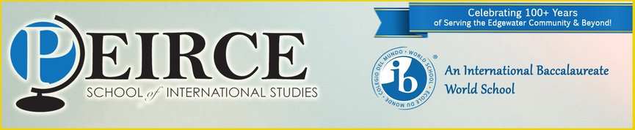

PEIRCE PRESCHOOL
2019-2020

Apply Online at www.chicagoearlylearning.org on April 15th, 2019
***Families will be informed of their acceptance on May 15th, 2019***

Peirce School of International Studies will have 7 classrooms for the 2019-2020 School Year! Three classrooms will be at Peirce School, and four classrooms will be at our new off-site location! More information to come this summer!

Call the Chicago Early Learning Hotline at (312) 229-1690 for more specific questions.

