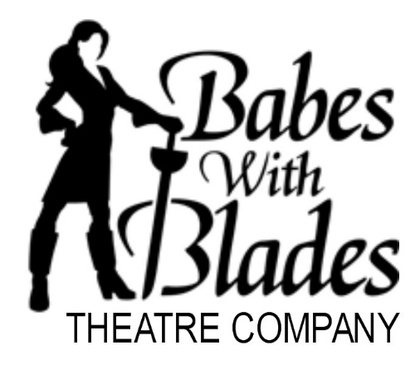
Babes With Blades Fundraising Event for DC Trip.
Have you ever been to our Nation’s capital? Maybe you went on a school trip! This year, for the first time in many years, the 7th and 8th grade students of Helen C. Peirce School will embark on this life-changing and exciting trip.

They just need a little help getting there.
Scholarships will be provided to those who apply. To help fund those scholarships we need your help! We need you and your friends to come to an amazing night of theatre!
Politics? Intrigue? Turning the status quo on its head?

Maybe that describes Washington D.C., but it also describes the Babes With Blades production of Henry V by William Shakespeare! This all female production paints the world as Henry the V ascends the throne after the death of his father and faces suspicion from within his country and pressure from without…..

Yes, All Female Henry V.
Director Hayley Rice says, “when you move beyond what’s considered traditional casting in classical works, it give the audience opportunity to look at the text with new eyes.” Click here to learn about the Babes with Blades Theatre Company.

The benefit performance will take place on Saturday, March 11, 2017 at 8:00 p.m. at City Lit Theatre 1020 W Bryn Mawr, 2nd floor.

Here are the details:
The Babes With Blades have set aside 50 tickets for this performance.
Each ticket is $35 and will benefit the scholarship fund for the 7th and 8th grade trip to Washington DC.
This show is appropriate for children who are avid readers and can process staged violence. 4th grade and up. What a way to introduce your kids to Shakespeare, World History, Gender Equality and Stage Combat all while benefiting an amazing trip for our awesome middle school.

You really cannot go wrong unless you wait! ONLY 50 tickets will be sold. Please visit www.friendsofpeirce.org to purchase your tickets online. The Peirce office staff will provide you with assistance in getting to the website as needed.

TICKETS WILL BE AVAILABLE AT WILL CALL
You will receive an email acknowledgement of your purchase with additional information about the Babes With Blades production. If you have any questions please contact Sara at sarakeelymcguire@gmail.com.

