Dear Students & Families,

With the upcoming closings and social distancing, therapeutic sessions between myself and students cannot formally take place via video chat or phone sessions. However, I am committed to making myself available to students and parents through email. Please feel free to reach out to me if you have any concerns or questions that arise over this break. I have compiled some activities that can be worked on at home so your student can continue to make progress towards their speech and language goals. These are not mandatory, but they are some good resources to continue targeting their skills during this time. For more information or questions, do not hesitate to reach out to me. I will genuinely miss meeting all of my students face-to-face, and I hope everyone stays safe and healthy!

Packet Content
- Language Activity Calendar
- Links to Worksheets and Activities at home

Sincerely,
Cassie Poulos (School Speech-Language Pathologist)
capoulos@cps.edu

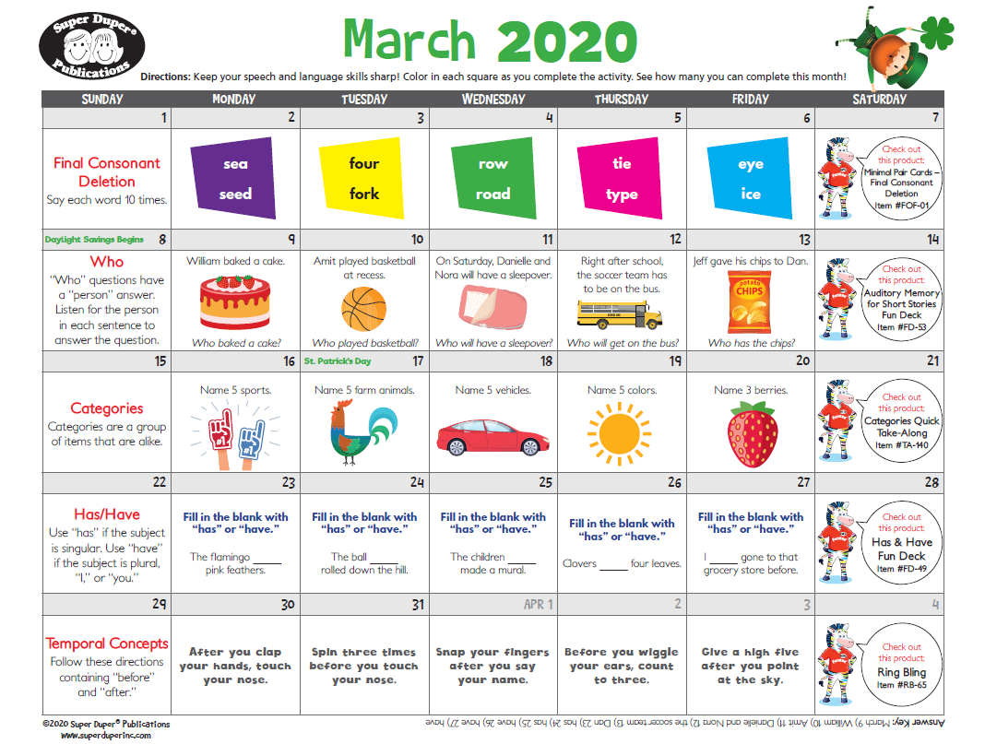
Language Activities and Online Resources
https://www.readworks.org

http://www.idiomconnection.com

https://do2learn.com/

Vocabulary Pinball - http://www.playkidsgames.com/games/pinball/default.htm?scrlybrkr=cdc7a5cd#

Infercabulary; www.infercabulary.com - Special offer of 2 free months -

Tracy Boyd’s online language games - Class Page - havefun

https://classroommagazines.scholastic.com/support/learnathome.html

Free parent Handouts for vocabulary, book/app suggestions and language strategies:
https://www.teacherspayteachers.com/Store/Lovecheck-Speech/Price-Range/Free/Category/Parent-Handout-417794

www.enchantedlearning.com/crafts/ - Great for following directions and sequencing

Tracy Boyd’s online language games - https://www.quia.com/pages/havefun.html

Highlights for Kids - www.HighlightsKids.com
-If you opt to play the game, give your child directions of what to look for and play. You can also have your child describe key features in the game or sequence the rules to the game.

Basic Concepts Scavenger Hunt:
https://www.handyhandouts.com/viewHandout.aspx?hh_number=582&nfp_title=No+Prep+Therapy+Activity+%E2%80%93+Basic+Concepts+Scavenger+Hunt

