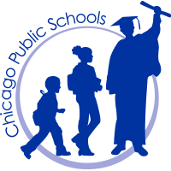
Peirce School of International Studies
An International Baccalaureate World School

PEIRCE LOCAL SCHOOL COUNCIL MEETING
Thursday, December 13, 2018
*****6:00 pm *****
Gymnatorium
NOTE: Please Enter at Door #8

AGENDA
- Chair Calls Meeting to Order
- Roll Call (In person, phone, video)
  - Approval of the Order of the Agenda
- Items Needing Council Approval
  - Minutes of the November 15, 2018
  - Minutes of the November 29, 2018 Special Meeting
- Student Council Report
- Public Participation
- Old Business
- New Business
  - Principal Evaluation
- Committee Reports
  - BAC
  - PAC
  - FOP
  - PPLC
  - PSO
  - Principal Evaluation
  - Safety & Security
  - Others
- Principal’s Report
  - Least Restrictive Environment
- Public Participation
- Fundraising
- Budget
- Transfer of Funds
  - Federal
  - State
- Internal Accounts
  - Approval of Internal Accounts
- Announcements
- Executive Session
- Motion to Adjourn

