Peirce School of International Studies
An International Baccalaureate World School
www.peirce.cps.k12.il.us
1423 W Bryn Mawr Ave, Chicago IL 60645
773.534.2440 (Phone) 773.534.2577 (Fax)

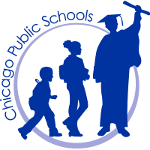

PEIRCE LOCAL SCHOOL COUNCIL
SPECIAL MEETING
Thursday, November 29, 2018
*****5:00 pm *****
Library
NOTE: Please Enter at Door #1

AGENDA

- Chair Calls Meeting to Order
- Roll Call
  - Approval of the Order of the Agenda
- Public Participation
- Old Business
- New Business
  - Principal Evaluation
- Announcements
- Executive Session
- Motion to Adjourn

